Abdominal wall
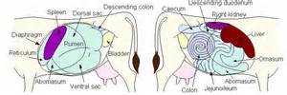

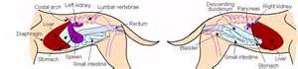
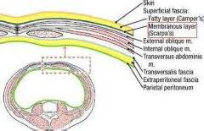

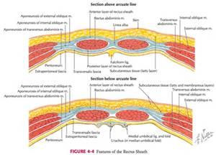

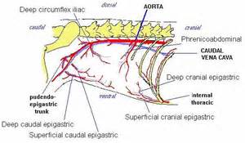

Wounds of the Abdominal Wall
Non perforating abdominal wounds:-
They are in the form of wounds or contusions of the skin, subcutaneous tissue and abdominal muscles without rupture or injury to th peritonium.
Causes:
- External trauma as motor car accident or kick from another animal or foreign body as by fork or barbed wire.
- In small animals, bites and passing through a glass window.
These wounds usually subjected to contamination and infection.
Contusions accompanied with hematoma and or rupture of the abdominal muscles are more liable for herniation.
Treatment:
- Wounds of the skin should be trimmed and sutured after local application of antibiotic or sulphonamide.
- The lowest part of the wound should be left unsutured and a piece of sterile gauze is applied in it for drainage. Wounds in the subcutaneous tissue and the muscles are treated in the same way.
- Purulent wound should not be sutured, they can be treated with 10 % iodoform ether.
- Haematoma can be opened 12th day after its formation and treated as usual.
Perforating abdominal wounds:-
Perforating abdominal wound with rupture of the peritonium:
- This form is not dangerous except in horses.
- Can detected by finger under aspect precautions.
- In recent cases, there is no general disturbances and the wound can be treated as normal with the application of systemic antibiotic.
- When the condition is longer than 1 - 2 days, peritonitis can be suspected which is accompanied by general disturbances, severe abdominal colicy pain, tenderness of the abdominal wall and vomition in small animals.
Treatment:
- Cleaning of the wound with hydrogen peroxide or saline, trimming the lips of the wound and suturing of all layers after application of antibiotics.
Perforating abdominal wounds with prolapse of the omentum:
- This form is favorable because the omentum closes the wound and prevent infection to go inside.
Treatment:
- The prolapsed omentum should be slightly withdrawn and throughly washed with saline solution or warm water.
- A ligature is made at its base and cut the protruded part and return the omentum to the abdomen.
- The abdominal wound is then sutured in several layers.
Perforating abdominal wounds with prolapse of intestine :
This forms of wounds are unfavourable, especially of the animal is permited for surgery several hours after the occurance of the accident, due to necrosis and dryness of the peritoneum.
Treatment:
- Washing the prolapsed intestine with warm saline solution and reduce it as quickly as possible.
- The lips of the wound are cleaned and trimmed and then sutured.
Perforating abdominal wounds with injury to the prolapsed intestine:
- These are the most dangerous form.
- May end with an intestinal fistula.
Treatment:
Intestinal resection and anastomosis.

